**EXPERIMENT – 5**

**TITLE: Interface**

1. **Write a program to create interface named test. In this interface the member function is square. Implement this interface in arithmetic class. Create one new class called ToTestInt. In this class use the object of arithmetic class.**

interface test{

public void square(int a);

}

class Arith implements test{

public void square(int a){

int b=a*a;

System.out.println("square is"+b);

}

}

class ToTestInt{

public static void main(String args[]){

Arith a1=new Arith();

a1.square(2);

}

}

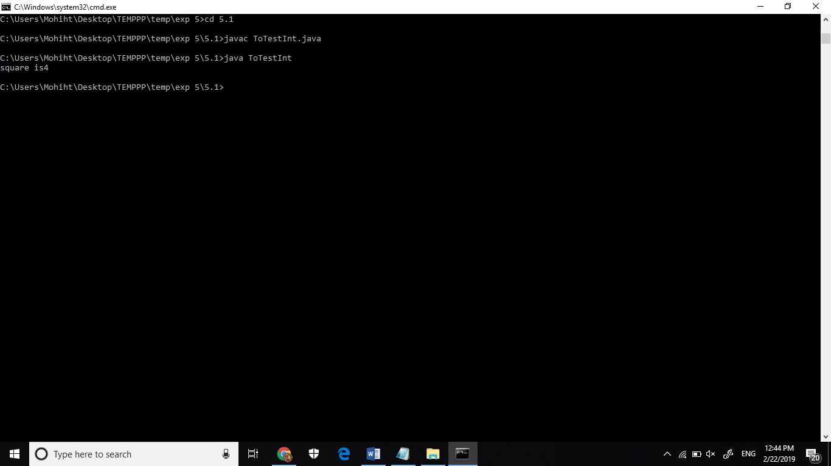

1. **Write a program to create interface A, in this interface we have two method meth1 and meth2. Implements this interface in another class named MyClass.**

interface A {

public void meth1();

public void meth2();

}

class Myclass implements A {

public void meth1(){

System.out.println("this is method 1");

}

public void meth2(){

System.out.println("this is method 1");

}

public static void main(String args[]){

Myclass m1= new Myclass();

m1.meth1();

m1.meth2();

}

}

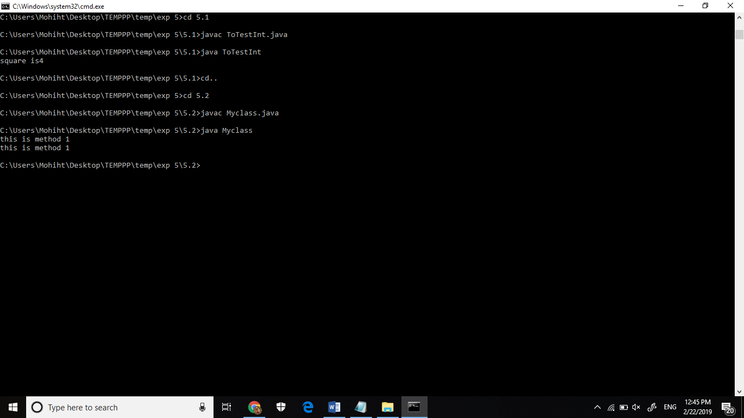

1. **Write a program in Java to show the usefulness of Interfaces as a place to keep constant value of the program**

interface area

{

static final float pi=3.142f;

float compute(float x,float y);

}

class rectangle implements area

{

public float compute(float x,float y)

{return(x*y);}

}

class circle implements area

{

public float compute(float x,float y)

{return(pi*x*x);}

}

class driver

{

public static void main(String args[])

{

rectangle r1=new rectangle();

circle c1=new circle();

System.out.println("Area of the rectangle= "+r1.compute(20,30));

System.out.println("Area of the circle= "+c1.compute(30,0));

}

}

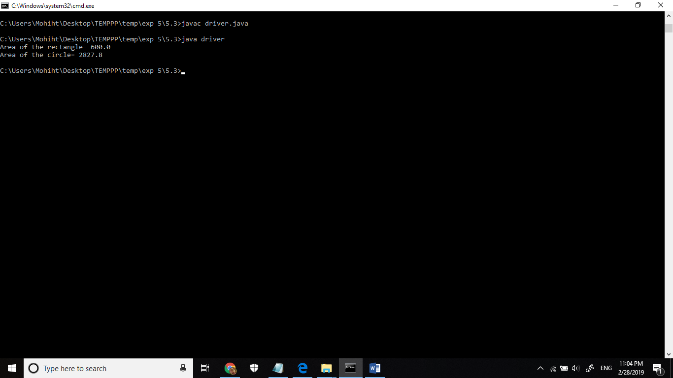

1. **Write a program to create an Interface having two methods division and modules. Create a class, which overrides these methods.**

interface hello{

public void division();

public void modules();

}

class overide implements hello{

public void division(){

System.out.println("this will print: result of overiding");

}

public void modules(){

System.out.println("this will print: result of overiding too");

}

}

class tester{

public static void main(String args[]){

overide o1= new overide();

o1.division();

o1. modules();

}

}

